FIFTEEN SHARDS OF LIGHT

Level_03
Gameplay Map and Complete Level Design Specification
v1.1
  - «После наших разговоров»

FINAL LEVEL DESIGN VERDICT
READY FOR GODOT TECHNICAL ARCHITECTURE AFTER PRODUCER APPROVAL. This document does not authorize runtime implementation, a greybox PR, Blender/GLB production, Art Production Bible work or Codex implementation decomposition.

Control | Value
Project | Fifteen Shards of Light
Repository | MindDevastation/fifteen-shards-of-light
Target scene | res://scenes/levels/Level_03.tscn
Document | Level_03_Gameplay_Map_and_Level_Design_Spec_v1.1.docx
Version / date | 1.1 / 22 June 2026
Mode | Documentation only - authorizes no runtime, greybox PR, Blender/GLB or Codex implementation work
Primary narrative authority | Level_03_Narrative_and_Level_Scenario_Package.docx
Primary visual authority | Level_03_Visual_Master_Concept_Package_v1.1.docx
Portal target | res://scenes/levels/Level_04.tscn

Self-contained gameplay-design authority for Producer review and the subsequent Godot Technical Architecture stage

Contents
- 1. Source hierarchy and repository snapshot
- 2. Final design verdict and progression order
- 3. World coordinates, footprint and exact layout
- 4. Traversal geometry, clearances and recovery
- 5. Beat-by-beat playable flow and pacing
- 6. Shard_05 and Wind Trace specification
- 7. Shard_06 and Playful Spark specification
- 8. Shard_07 and Breathing Meadow specification
- 9. Environment state progression
- 10. Main-text gate, portal and level exit
- 11. Progress preservation, duplicate events and reload policy
- 12. Guidance and accessibility
- 13. Failure / softlock matrix
- 14. Acceptance criteria and manual playtest matrix
- 15. Simplification fallback and technical handoff boundary
- 16. Producer decision table

Executive summary
Level_03 is specified as one continuous, broad and safe S-shaped walk above soft fog. The level contains three sequential emotional beats - Wind Trace, Playful Spark and Breathing Meadow - followed by a quiet synthesis at the Final Overlook. It deliberately rejects the current legacy placeholder structure of one shard, reveal-step platforms and a one-shard LevelManager loop.
The proposed playable envelope is 44 m wide by 106 m long, with a 5.5 m minimum mandatory route width, 0.0-1.6 m playable elevation change, no mandatory gaps and no mandatory steps higher than 0.15 m. The expected first completion is 5:30-7:00, with 8:00 treated as the scope alarm threshold.
ORDER DECISION
Hybrid. Macro progression is linear: Shard_05 -> Shard_06 -> Shard_07 -> main text -> portal. This order is required by the narrative arc from remembered intonation, to sudden laughter, to the author's own lightness. Inside Breathing Meadow, the three wind-petals are persistent and may be activated in any order.

Version 1.1 change log
ID | Mandatory revision | v1.1 result
V11-01 | Production gate | Only Godot Technical Architecture may follow Producer approval.
V11-02 | Portal anchor | Replaced independent visual/trigger coordinates and radius with one LevelPortalRoot / PortalFloorAnchor.
V11-03 | Portal contract | Locked AUTO_ENTER, no confirmation, portal-owned scene loading and target Level_04.
V11-04 | Early overlap | Added mandatory re-evaluation and exactly-once Level_04 transition contract.
V11-05 | Fall recovery | Explicit volumes only; removed ambiguous stuck timer; added one-teleport, velocity and lock rules.
V11-06 | Meadow order | Acceptance covers all six petal permutations.
V11-07 | P0 races | Added duplicate and fallback-race tests for petal, spark, text and portal.
V11-08 | Portal guidance | Removed pre-activation portal cue; landmark/ribbon/mote guidance only.
V11-09 | First arch | Unified inactivity threshold at 4 s.
V11-10 | Exact map | Re-exported with leader lines and corrected single portal root/floor anchor.
V11-11 | Player semantics | Added root-to-floor, grounding and floor-snap carry-over for Technical Architecture.
Preserved without change: route topology, footprint, route width, shard order and texts, puzzle order, Meadow proximity dwell, environment states E0-E6, clean full-scene reload reset and Level_04 target.

1. Source hierarchy and repository snapshot
Priority | Source | Authority in this document
1 | Narrative package | Exact shard IDs/texts, main text, emotional arc, scenario sequence and safety guardrails.
2 | Visual Master Concept v1.1 | Continuous S-shaped sky-grove, proportions, landmark hierarchy, visual puzzle form, environment language.
3 | Current repository state | Used to identify legacy drift and practical baseline only; placeholder is not gameplay canon.
4 | This gameplay specification | Exact gameplay coordinates, dimensions, deterministic puzzle rules, no-softlock and acceptance contracts; input to Godot Technical Architecture only after Producer approval.

Repository datum | Verified design implication
Current Level_03 scene SHA | 1d8ee50989bbf9d06e8a1fb4f3fe11648b17182b
Current structure | One SoulShard, one LevelManager reward, four reveal-step platforms, three reveal triggers.
Current player-facing placeholder | «Не нужно видеть весь путь сразу — достаточно следующего шага» - remove from planned player-facing flow.
Current portal target | res://scenes/levels/Level_04.tscn - keep.
Player collision reference | Box 0.706 x 1.728 x 0.522 m; required clearances in this spec exceed this envelope.
Runtime change status | None. This document does not modify the repository.

LEGACY REPLACEMENT RULE
StartGround / EndGround / Step01-04 / RevealTriggerA-C / one SoulShard / legacy PoemRewardUI flow are historical prototype elements. They may be removed or replaced during a later approved implementation stage; they do not constrain this level design.

2. Final design verdict and progression order
Decision | Status | Result
Macro topology | LOCKED | Continuous asymmetrical S-route with three expansions. No hub, circular arena or trial spokes.
Shard count / IDs | LOCKED | Exactly Shard_05, Shard_06 and Shard_07.
Macro order | LOCKED BY THIS SPEC | Linear emotional order: intonation -> laughter -> author becomes lighter.
Meadow order | LOCKED BY THIS SPEC | Three visible petal targets, any order, persistent.
Breathing Meadow verb | RECOMMENDED | Safe proximity dwell 0.65 s; avoids a repeated collectible-style E interaction.
Final gate | LOCKED BY THIS SPEC | All three unique shard rewards complete + player at Final Overlook.
Portal timing | LOCKED | Dormant through main text; forms only after main text closes.

2.1 Why fully free shard order is rejected
- Shard_05 establishes the remembered intonation after a conversation; it is the quiet opening observation.
- Shard_06 escalates into the concrete, playful detail of sudden laughter.
- Shard_07 is explicitly the author's response to the previous experiences: he laughs more and becomes less serious.
- Reordering Shard_07 before Shard_05 or Shard_06 weakens the causal emotional sentence in the main text.
- A linear macro-flow also protects the 5:30-7:00 duration budget and prevents open-world searching in a small personal game.

2.2 Why local freedom is retained
The three wind-petals are not three different narrative claims. They are three equal facets of one emotional release. Any-order activation therefore supports calm exploration without damaging narrative order.

3. World coordinates, footprint and exact layout

3.1 Coordinate convention
Convention | Definition
Origin | Vector3(0, 0, 0) at the route transition into Playful Glade; used as a stable gameplay-coordinate reference.
Forward | +Z from Quiet Inlet toward Final Overlook.
Lateral | +X is player-right when facing +Z; -X is player-left.
Elevation | Y is floor elevation; required playable floor range 0.00-1.60 m.
Coordinates | Proposed gameplay anchors are authoritative within ±0.5 m. Gameplay targets should not move without design review.
Art dressing tolerance | Non-gameplay vegetation/ruins may shift ±1.5 m if route width, visibility and camera margins remain compliant.

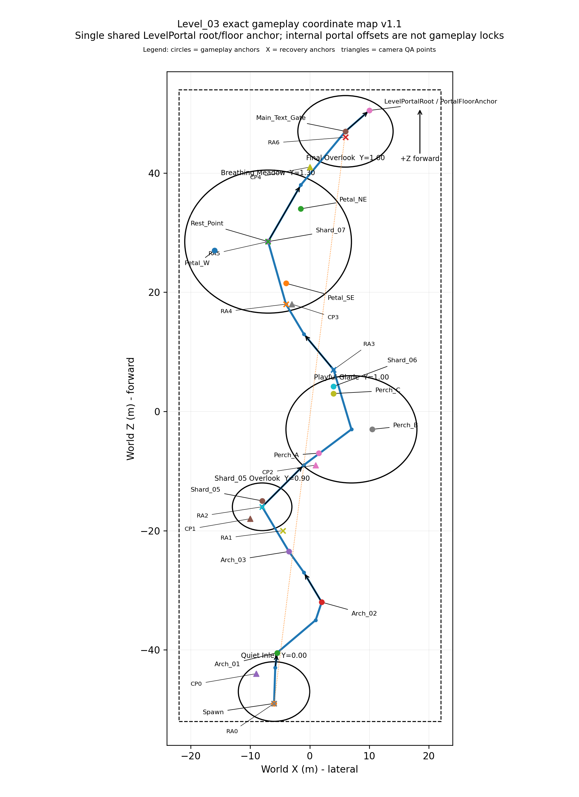
Figure 1. Exact proposed gameplay coordinate map v1.1. Leader lines separate the Shard_05, Meadow and final portal clusters; only the shared LevelPortal root/floor anchor is locked.

3.2 World footprint and zone dimensions
Area | Position | Plan size | Elevation | Gameplay function
Overall gameplay envelope | X -22 to +22 | Z -52 to +54 | 44 x 106 m | Fits visual target 96-110 m long x 38-48 m wide.
Quiet Inlet | Center (-6, 0, -47) | 12 x 10 m oval | Y 0.00 | Safe spawn shelf.
Wind Trace corridor | S-route, P01-P06 | 5.5 m min width | Y 0.08-0.80 | Three arches, no gaps.
Shard_05 Overlook | Center (-8, 0.90, -16) | 10 x 8 m oval | Y 0.90 | Safe reading area; shard >2.5 m from edge.
Playful Glade | Center (7, 1.00, -3) | 22 x 18 m oval | Y 1.00 | All 3 perches readable in one composition.
Connector / Exhale | P10-P12 | 5.5-6.0 m width | Y 1.05-1.28 | No new rule.
Breathing Meadow | Center (-7, 1.30, 28.5) | 28 x 24 m oval | Y 1.30 | All three petals visible from entry.
Final Overlook | Center (6, 1.60, 47) | 16 x 12 m oval | Y 1.60 | Main text gate + dormant portal core.

3.3 Route centerline control points
Point | X | Y | Z | Use
P00 Spawn | -6.00 | 0.00 | -49.00 | Required centerline / smooth interpolation
P01 Inlet exit | -5.80 | 0.08 | -43.00 | Required centerline / smooth interpolation
P02 Arch 01 | -5.50 | 0.15 | -40.50 | Required centerline / smooth interpolation
P03 Curve east | 1.00 | 0.35 | -35.00 | Required centerline / smooth interpolation
P04 Arch 02 | 2.00 | 0.45 | -32.00 | Required centerline / smooth interpolation
P05 Curve west | -1.00 | 0.65 | -27.00 | Required centerline / smooth interpolation
P06 Arch 03 | -3.50 | 0.80 | -23.50 | Required centerline / smooth interpolation
P07 Shard 05 overlook | -8.00 | 0.90 | -16.00 | Required centerline / smooth interpolation
P08 Glade approach | -1.00 | 0.95 | -9.00 | Required centerline / smooth interpolation
P09 Playful Glade center | 7.00 | 1.00 | -3.00 | Required centerline / smooth interpolation
P10 Glade exit | 4.00 | 1.05 | 7.00 | Required centerline / smooth interpolation
P11 Exhale bend | -1.00 | 1.15 | 13.00 | Required centerline / smooth interpolation
P12 Meadow entry | -4.00 | 1.28 | 18.00 | Required centerline / smooth interpolation
P13 Meadow center | -7.00 | 1.30 | 28.50 | Required centerline / smooth interpolation
P14 Final approach | -1.50 | 1.45 | 38.00 | Required centerline / smooth interpolation
P15 Final Overlook | 6.00 | 1.60 | 47.00 | Required centerline / smooth interpolation
P16 LevelPortalRoot | 10.00 | 1.60 | 50.50 | Required route endpoint / shared LevelPortal root-floor placement anchor

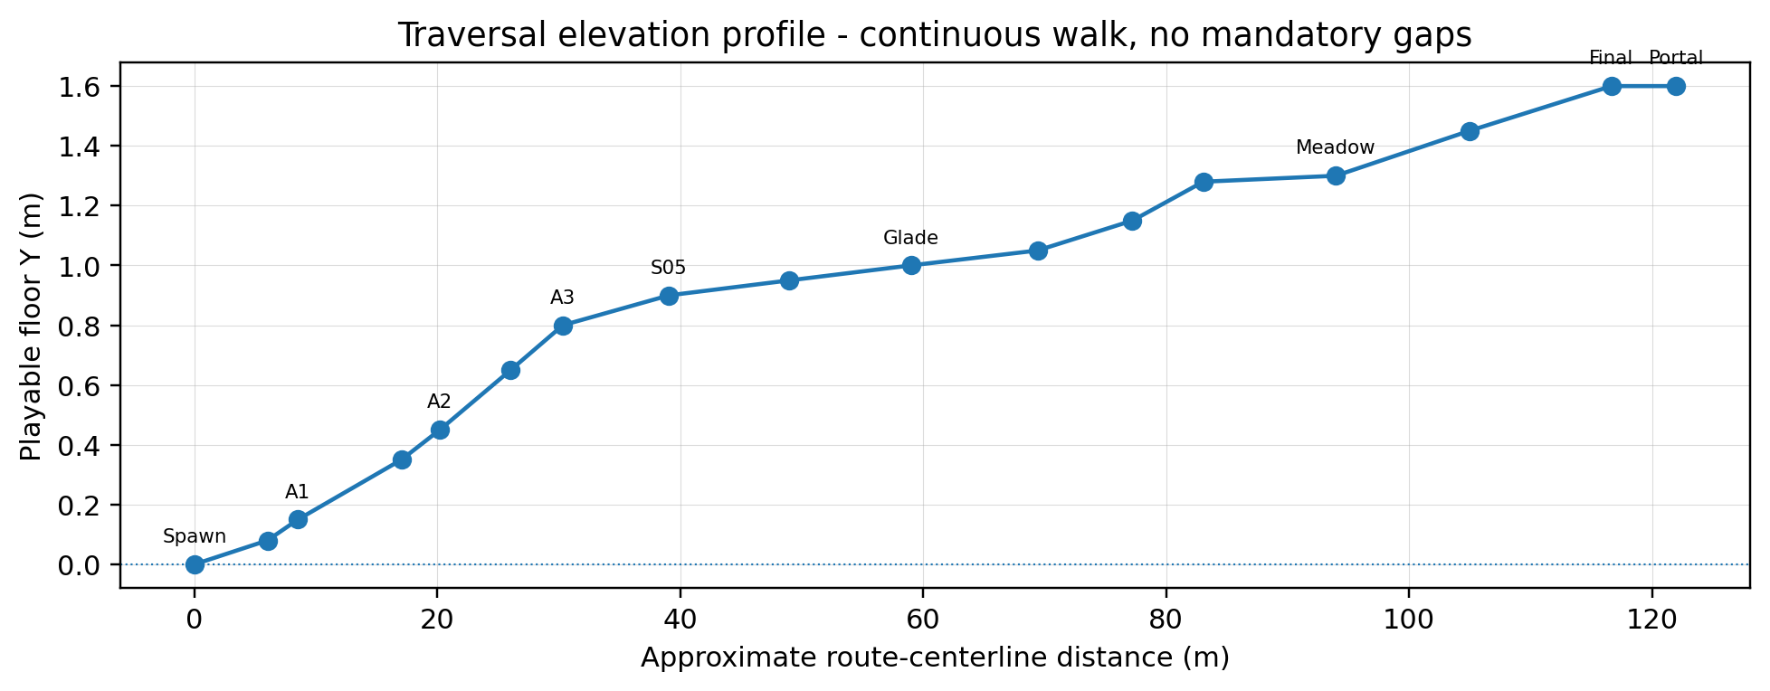
Figure 2. Route elevation profile. Godot Technical Architecture must validate the traversal profile without adding mandatory jumps or abrupt stairs.

3.4 Exact gameplay anchors
Anchor | Vector3 | Function
Spawn | (-6.00, 0.65, -49.00) | Spawn / facing +Z
Arch_01 | (-5.50, 0.15, -40.50) | Wind Trace 1
Arch_02 | (2.00, 0.45, -32.00) | Wind Trace 2
Arch_03 | (-3.50, 0.80, -23.50) | Wind Trace 3
Shard_05 | (-8.00, 2.00, -15.00) | Reward: intonation
Perch_A | (1.50, 1.05, -7.00) | Spark start
Perch_B | (10.50, 1.05, -3.00) | Spark hop 2
Perch_C | (4.00, 1.05, 3.00) | Spark hop 3
Shard_06 | (4.00, 2.00, 4.20) | Reward: laughter
Petal_W | (-16.00, 1.30, 27.00) | Any-order target
Petal_SE | (-4.00, 1.30, 21.50) | Any-order target
Petal_NE | (-1.50, 1.35, 34.00) | Any-order target
Rest_Point | (-7.00, 1.30, 28.50) | 3-segment progress
Shard_07 | (-7.00, 2.20, 28.50) | Reward: ease
Main_Text_Gate | (6.00, 1.60, 47.00) | R=4.5 m
LevelPortalRoot / PortalFloorAnchor | (10.00, 1.60, 50.50) | Single shared LevelPortal root/floor placement anchor. Internal visual and interaction offsets are owned by the shared scene.

3.5 Camera QA and preview points
Point | Position | Target | Rule
CP0 Arrival | (-9.0, 5.5, -44.0) | Look at (6.0, 2.5, 47.0) | QA/framing reference only; no long forced camera lock.
CP1 Shard05 | (-10.0, 5.0, -18.0) | Look at (7.0, 1.0, -3.0) | QA/framing reference only; no long forced camera lock.
CP2 Glade | (1.0, 6.0, -9.0) | Look at (7.0, 1.0, -3.0) | QA/framing reference only; no long forced camera lock.
CP3 Meadow | (-3.0, 7.0, 18.0) | Look at (-7.0, 1.3, 28.5) | QA/framing reference only; no long forced camera lock.
CP4 Final | (0.0, 6.0, 41.0) | Look at (6.0, 1.6, 47.0) | QA/framing reference only; no long forced camera lock.

4. Traversal geometry, clearances and recovery
Parameter | Locked gameplay rule
Mandatory route width | 5.5 m minimum; 6.0-7.0 m at turns, puzzle entrances and reward areas.
Route shoulder | 1.5 m minimum clear shoulder beyond walkable surface before dense props/blockers.
Safe camera corridor | 8.5 m total clear corridor around mandatory path centerline; tall props outside this corridor.
Maximum preferred slope | 8 degrees; absolute isolated maximum 10 degrees over <=4 m.
Cross-slope | <=3 degrees on mandatory traversal and puzzle surfaces.
Mandatory step height | <=0.15 m; use continuous ramp/terrain blend for larger elevation change.
Mandatory gap | None. Visual cracks <=0.10 m and collision must remain continuous.
Arch clear width | 6.5 m minimum internal width.
Arch overhead clearance | 5.2 m minimum above floor.
Puzzle target clearance | 3.0 m clear radius around shard, perches and petals; no camera-blocking vertical prop inside.
Reward reading safety | Shard collection positions >=2.5 m from a fall edge and on <3 degree floor.
Visual boundary collision belt | 1.0-1.5 m thick behind natural edge composition; never encroach on camera corridor.

4.1 Technical carry-over: Player root-to-floor semantics
The current Player collider is vertically offset from the CharacterBody3D root. Godot Technical Architecture must validate root-to-floor semantics, grounding, floor snap, spawn placement and recovery placement against the actual shared Player scene. Spawn or return height must not be derived mechanically from half the collider height.

4.2 Fall recovery policy
The level has no death and no mandatory gaps. Recovery is triggered only by an explicit SoftReturnVolume below the playable world or by explicit authored out-of-bounds recovery volumes. Standing still, moving slowly, touching a normal blocker or remaining near legal side spaces and overlooks never causes recovery. Optional stuck detection is outside the MVP unless separately specified and approved.
Anchor | Return position | Activation rule
RA0 | (-6.00, 0.65, -49.00) | Becomes current after the player safely reaches this route milestone.
RA1 | (-4.50, 0.95, -20.00) | Becomes current after the player safely reaches this route milestone.
RA2 | (-8.00, 1.00, -16.00) | Becomes current after the player safely reaches this route milestone.
RA3 | (4.00, 1.10, 7.00) | Becomes current after the player safely reaches this route milestone.
RA4 | (-4.00, 1.35, 18.00) | Becomes current after the player safely reaches this route milestone.
RA5 | (-7.00, 1.40, 28.50) | Becomes current after the player safely reaches this route milestone.
RA6 | (6.00, 1.70, 46.00) | Becomes current after the player safely reaches this route milestone.

- Each fall event produces exactly one teleport, using a short 0.25-0.40 s fade and no failure text, damage, score loss or puzzle reset.
- Puzzle progress, collected shards and environment state remain unchanged; linear and angular velocity are reset on return.
- The return position must be validated as grounded and at least 1.5 m from active puzzle triggers; recovery volumes may not overlap legal side spaces or overlooks.
- Recovery is suspended while a shard-reward or main-text control lock is active. If the latest anchor is invalid, fall back through earlier anchors; RA0 is the guaranteed final fallback.

5. Beat-by-beat playable flow and pacing
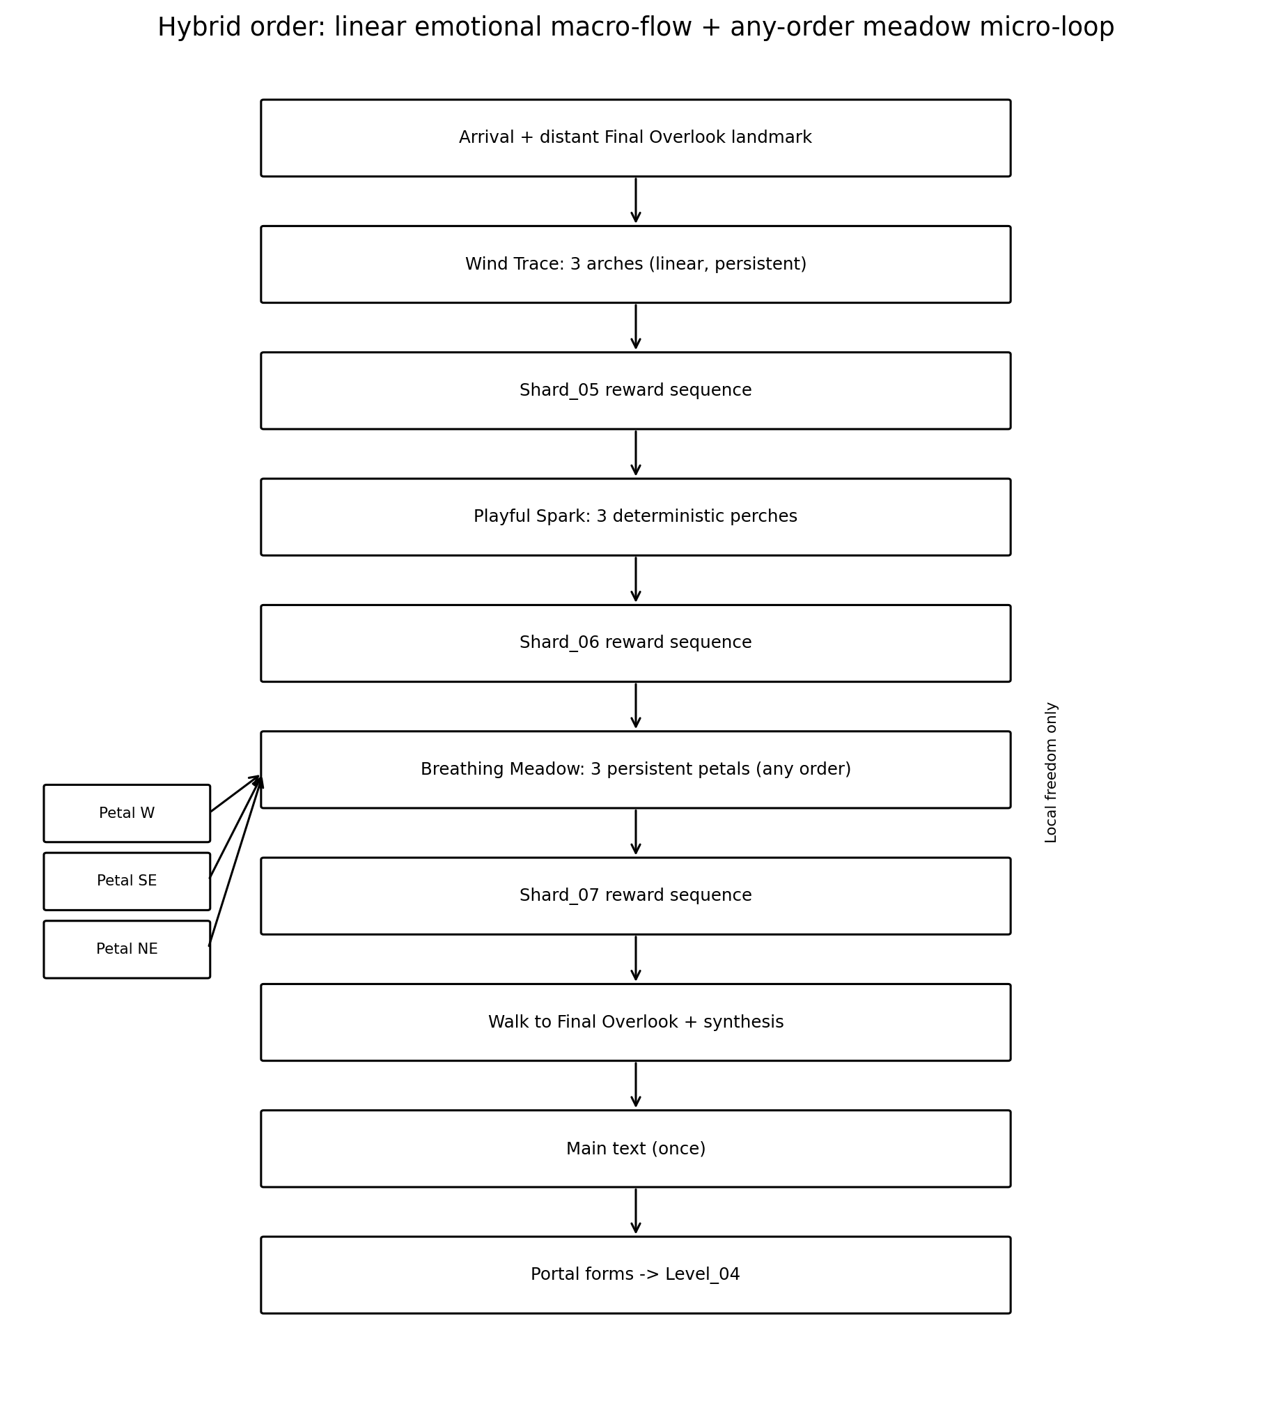
Figure 3. Canonical hybrid progression order.
ID | Beat | Budget | Location | Goal | Landmark | Action | Narrative | Reaction | Confusion | Fallback
B00 | Arrival | 0:00-0:20 | Quiet Inlet / Spawn | Orient, test movement | Final Overlook silhouette | Move/rotate camera | Expectation | Natural color at 72% richness; one ribbon | Player turns backward | Arch_01 pulses after 4 s without meaningful movement or camera change.
B01 | Activity confirmation | 0:05-0:25 | Spawn shelf | Recognize forward route | Arch_01 | Meaningful movement input or camera change; otherwise auto-pulse at 4 s. | Invitation, not command | Wind ripple wakes softly | No input | Use the same 4 s threshold; no alternate timing path.
B02 | Wind Trace 1 | 0:20-0:40 | P01-P02 | Pass Arch_01 | Arch_02 glow | Walk through volume | Intonation leaves first trace | Grass wave toward Arch_02 | Miss activation edge | Wide full-path volume
B03 | Wind Trace 2 | 0:40-0:58 | P03-P04 | Pass Arch_02 | Arch_03 silhouette | Walk | Lingering memory | Ribbon continues | Walk past inactive Arch_03 | Only current arch pulses
B04 | Wind Trace 3 | 0:58-1:15 | P05-P06 | Complete trace | Shard_05 Overlook | Walk | Trace resolves | Overlook gains warm accent | Player stops | Escalating pulse after 20/35 s
B05 | Shard_05 reveal | 1:15-1:25 | Overlook | Approach shard | Shard_05 | E collect when available | Specific memory of intonation | 0.8 s reveal, safe floor | Tries before reveal | Interaction disabled until available
B06 | Shard_05 reward | 1:25-1:45 | Overlook | Read short phrase | Playful Glade in view | Existing reward sequence | Personal specificity | Ribbons clearer; glade warmer | Overlay interrupted | Fallback completion; no softlock
B07 | Glade approach | 1:45-2:05 | P07-P08 | Enter glade | Perch_A and warm impulse | Walk | Shift from memory to play | Motes lead forward | Runs ahead | Spark remains locked until reward complete
B08 | Playful Spark A | 2:05-2:22 | Glade south-west | Approach current perch | Perch_B preglow | Proximity | Unexpected laugh begins | Hop A->B | Approaches wrong perch | No penalty; current perch pulses
B09 | Playful Spark B | 2:22-2:42 | Glade east | Follow hop | Perch_C preglow | Proximity | Shared playful rhythm | Hop B->C | Leaves glade | Stage persistent
B10 | Playful Spark C | 2:42-3:02 | Glade north | Complete sequence | Seed-pod cluster | Proximity | Ordinary thing becomes funny | Pods react; shard revealed | Player stands at landing | Settle delay prevents accidental chain
B11 | Shard_06 reward | 3:02-3:28 | Glade north | Collect/read | Connector / meadow silhouette | E + reward sequence | Her sudden laughter | Warm motes move onward | Duplicate collect | Unique-ID duplicate ignored
B12 | Exhale connector | 3:28-3:52 | P10-P12 | Walk without new rule | Three meadow petals | Walk | Pause after laughter | Reduced prop density | Searches for puzzle | All petals visible from entry
B13 | Meadow introduction | 3:52-4:05 | Meadow entrance | Read any-order targets | 3 petals + central rest point | Observe / move | Space opens | Each petal breathes once | Does not understand | Nearest petal preglow
B14 | Petal activation 1 | 4:05-4:25 | Any target | Stay near target | Rest point 1/3 | 0.65 s safe dwell | First release | Local haze clears | Leaves early | Dwell resets only
B15 | Petal activation 2 | 4:25-4:45 | Any target | Activate second | Rest point 2/3 | Safe dwell | More room to breathe | Second local clearing | Re-enters completed petal | No duplicate; remain complete
B16 | Petal activation 3 | 4:45-5:05 | Any target | Activate final | Shard_07 at center | Safe dwell | Author becomes lighter | All motifs converge softly | No progress for 25 s | Mote trail on nearest inactive
B17 | Shard_07 reward | 5:05-5:32 | Meadow center | Collect/read | Final Overlook becomes fully readable | E + reward sequence | Emotional culmination | 6 s nonblocking synthesis begins | Collect during reveal | Interaction disabled until reveal complete
B18 | Final approach | 5:32-5:55 | P13-P15 | Walk to overlook | Final landmark + dormant portal core | Walk | Quiet understanding | Ripple/spark/petals guide route | Does not return | Landmark pulses after 30/60 s
B19 | Main-text gate | 5:55-6:25 | Final Overlook | Enter gate/read text | Horizon | Presence + overlay close | Three details become one truth | Portal remains dormant during text | Already in gate | Automatic re-evaluation
B20 | Portal formation | 6:25-6:42 | Final Overlook | Wait for calm formation | Dormant shared LevelPortal root | No input required | Transition, not trophy | 1.8 s local formation | Optional presentation missing | 2.5 s fallback completes activation through the shared portal contract.
B21 | Exit | 6:42-7:00 | Portal | Enter Level_04 | Active shared LevelPortal | AUTO_ENTER; no confirmation | Gentle continuation | Local particles only | Portal entered early | Early overlap is re-evaluated after activation; no exit/re-enter required.

5.1 Duration budget
Segment | Target | Hard review threshold | Interpretation
Arrival + Wind Trace + Shard_05 | 1:25-1:45 | <=2:00 | More than 2:00 usually means arch guidance is weak.
Playful Glade + Shard_06 | 1:15-1:40 | <=2:00 | No chase, no wait timer, no hidden perch.
Connector + Meadow + Shard_07 | 1:35-2:05 | <=2:30 | Any-order loop should not become search.
Final approach + text + portal | 0:55-1:20 | <=1:30 | No long cinematic; text is the only intentional pause.
Total first completion | 5:30-7:00 | 8:00 scope alarm | Exclude deliberate idling; include normal reading.
Correct repeat completion | 3:00-4:00 | 4:30 maximum | All rules known; no reward-text reread assumption required.

6. Shard_05 and Wind Trace specification
LOCKED SHARD_05 TEXT
«После наших разговоров я ещё долго вспоминаю твою интонацию.»

Field | Specification
Prerequisite | Arch_01, Arch_02 and Arch_03 activated in order.
Reveal position | Vector3(-8.00, 2.00, -15.00), safe overlook centerline.
Reveal | 0.8 s: ribbon curls inward, shard fades/raises into available state.
Collection input | Existing shard interaction; unavailable before reveal completes.
Reward sequence | Existing short-reward presentation; one-time.
Environment effect | Over 4-5 s, wind ribbons and grass responses become clearer; warm accent appears toward Playful Glade.
Progress preservation | All arches and shard state remain complete during the current scene; leaving/re-entering never resets.

6.1 Wind Trace deterministic rules
Rule | Final specification
Objects | Exactly 3 broad arches on the continuous route.
Input | Player locomotion through the currently active arch volume.
Order | Arch_01 -> Arch_02 -> Arch_03. Later arches do nothing until active.
First teaching beat | Arch_01 pulses automatically after 4 s without meaningful movement or camera change and points toward Arch_02.
Success feedback | Current arch settles; grass ripple and light ribbon travel to next arch; next arch glow strengthens.
Wrong input | None. Walking around or crossing a future arch causes no penalty and no reset.
Leave / re-enter | Current progress persists. The active arch resumes its hint cadence.
Assistance | 20 s without progress: stronger glow. 35 s: ripple repeats every 5 s until progress.
No-softlock contract | All route surfaces always exist; each arch uses a full-width activation volume; if optional VFX is missing, progression still advances.
Activity confirmation timing | One value everywhere: 4 s without meaningful movement or camera change. Any meaningful activity cancels the automatic wait and allows the normal immediate teaching response.

State | Entry condition | Persistent result
DORMANT | Before player activity | Arch_01 quiet but visible
ARCH_01_ACTIVE | Activity confirmed | Arch_01 pulse + route ripple
ARCH_02_ACTIVE | Arch_01 crossed | Arch_02 highlighted
ARCH_03_ACTIVE | Arch_02 crossed | Arch_03 highlighted
TRACE_COMPLETE | Arch_03 crossed | Shard_05 reveal begins
SHARD_AVAILABLE | Reveal complete | Shard can be collected
COMPLETE | Shard reward complete | Playful Spark becomes armed

7. Shard_06 and Playful Spark specification
LOCKED SHARD_06 TEXT
«Мне особенно нравится, как ты вдруг смеёшься над какой-нибудь полной ерундой.»

Field | Specification
Prerequisite | Shard_05 reward sequence complete and spark has reached Perch_C.
Reveal position | Vector3(4.00, 2.00, 4.20), inside safe north glade area.
Reveal | 1.0-1.2 s seed-pod response; shard rises only after final hop settles.
Collection input | Existing shard interaction; disabled during reveal.
Reward sequence | One-time short reward.
Environment effect | Warm motes move toward the meadow; midground haze softens over 4 s; no global flash.
Progress preservation | Current perch index, completed hops and shard state persist while scene remains loaded.

7.1 Exact perch layout and sequence
Perch | Position | Role
Perch_A | Vector3(1.50, 1.05, -7.00) | Spark initial rest point; visible from glade entry.
Perch_B | Vector3(10.50, 1.05, -3.00) | Second landing; eastern side, no edge risk.
Perch_C | Vector3(4.00, 1.05, 3.00) | Final landing; adjacent to shard reveal cluster.

Rule | Final specification
Input | Approach the current spark perch within 3.0 m.
Determinism | Fixed sequence A -> B -> C. No random destination in first playable.
Destination telegraph | Next perch glows for 0.55 s before the 0.75-0.90 s hop.
During hop | All proximity triggers ignored; player movement remains free.
Arrival settle | 0.65 s settle before the next approach can trigger another hop.
Wrong input | Approaching an inactive future perch has no effect and no negative feedback.
Leave / re-enter | Spark waits indefinitely at current perch; current stage does not reset.
Assistance | 15 s idle: current perch pulses. 30 s: a short curved hint ribbon points to the current perch.
Frame safety | All perches are visible from the glade entry and remain inside one camera-readable oval composition.
No-softlock contract | If spark travel VFX cannot complete, the spark appears at the destination after 1.2 s and advances state.

State | Entry condition | Result
LOCKED | Before Shard_05 reward completion | Visible ambient perches; no spark input.
INTRO | Player enters armed glade | Spark appears at A; B briefly previews.
AT_A | Intro complete | Approach A triggers hop to B.
HOP_A_B | A approached | Input ignored; destination B preglow.
AT_B | Hop complete + settle | Approach B triggers hop to C.
HOP_B_C | B approached | Input ignored; destination C preglow.
AT_C | Hop complete + settle | Seed-pod reveal sequence.
SHARD_AVAILABLE | Reveal complete | Shard_06 can be collected.
COMPLETE | Shard reward complete | Breathing Meadow becomes armed.

8. Shard_07 and Breathing Meadow specification
LOCKED SHARD_07 TEXT
«Рядом с тобой я и сам чаще смеюсь и ненадолго перестаю быть таким серьёзным.»

Field | Specification
Prerequisite | Shard_06 reward complete and all three unique wind-petals activated.
Reveal position | Vector3(-7.00, 2.20, 28.50), directly above central rest point.
Reveal | 1.0 s central convergence after third petal; all completed petals remain visible.
Collection input | Existing shard interaction; disabled until convergence finishes.
Reward sequence | One-time short reward.
Environment effect | 6 s nonblocking synthesis: ripple, spark motes and petal drift visually lead toward Final Overlook.
Progress preservation | Per-petal completion is persistent; order is irrelevant; duplicate activations ignored.

8.1 Activation-verb decision
RECOMMENDED GAMEPLAY LOCK
Use safe proximity dwell, not E. Each petal activates after the grounded player remains within a 2.4 m zone for 0.65 s. This creates a calm spatial action, differentiates the beat from shard collection and avoids three repeated interaction prompts.

Object | Position | Role
Petal_W | Vector3(-16.00, 1.30, 27.00) | West edge; broad sightline from meadow entry.
Petal_SE | Vector3(-4.00, 1.30, 21.50) | Nearest teaching target; receives initial preglow.
Petal_NE | Vector3(-1.50, 1.35, 34.00) | Far target; framed against open sky.
Rest_Point | Vector3(-7.00, 1.30, 28.50) | Three persistent progress segments + Shard_07 reveal.

Rule | Final specification
Visibility | All 3 targets visible from Vector3(-4, 1.28, 18) meadow entry.
Input | Grounded proximity dwell: radius 2.4 m, duration 0.65 s.
Pre-activation feedback | Petal gains restrained preglow and local grass leans during dwell.
Leave before completion | Only the current dwell meter resets; no global progress loss.
Success feedback | Petal lifts/drifts over 1.3-1.6 s; one rest-point segment lights; local haze reduces.
Order | Any order. Each petal has a unique persistent completion flag.
Wrong input | None. Revisiting a completed petal produces only a quiet completed-state pulse.
Assistance | 25 s without a new activation: nearest inactive petal gains a vertical mote trail. 45 s: trail repeats every 6 s.
Simultaneous activation | Targets are spaced so zones cannot overlap; only one dwell can progress at a time.
No-softlock contract | If petal presentation fails, its completion still counts after the 0.65 s dwell and the rest-point segment updates.

State | Entry condition | Persistent result
LOCKED | Before Shard_06 reward completion | Petals ambient only.
READY_0_3 | Meadow armed | Nearest petal receives one teaching breath.
ACTIVE_1_3 | Any first petal complete | 1 segment persistent.
ACTIVE_2_3 | Any second petal complete | 2 segments persistent.
CONVERGENCE | All 3 unique petals complete | Shard reveal; further dwell ignored.
SHARD_AVAILABLE | Reveal complete | Shard_07 can be collected.
COMPLETE | Reward complete | Final Overlook gate becomes armed.

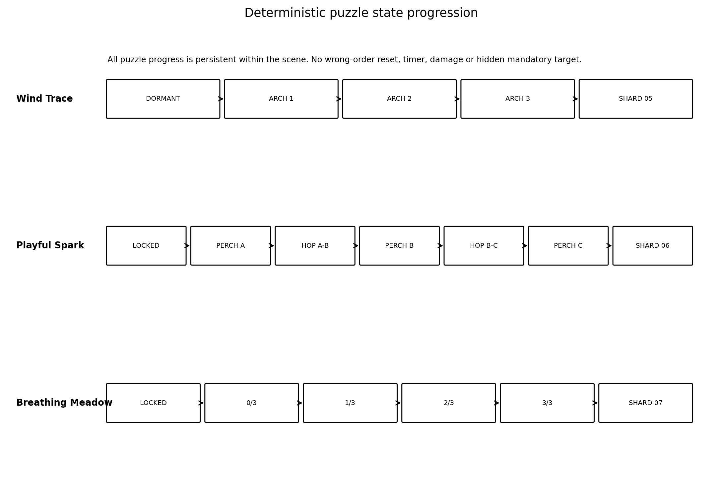
Figure 4. Puzzle progression states. Presentation failures may not block logical completion.

9. Environment state progression
State | Transition | Visual contract | Narrative meaning
E0 Initial | Start -> Shard_05 | Natural color richness target ~72% of final; cool/quiet, never gray. Mandatory route visible 18-22 m. Final landmark silhouette visible. | World is alive; player is beginning to notice.
E1 After Shard_05 | 4-5 s nonblocking | Ribbon contrast and coordinated grass motion increase; Playful Glade gains warm local accent. | Her intonation remains after the conversation.
E2 After Shard_06 | 4 s nonblocking | Warm motes and spark trail extend forward; midground haze softens; overall warmth increases slightly. | A sudden laugh makes an ordinary moment lighter.
E3 Meadow 1/3 | 1.5 s local | One local haze pocket clears; rest point 1/3. | First release of tension.
E4 Meadow 2/3 | 1.5 s local | Second local pocket clears; rest point 2/3. | Space becomes easier to read.
E5 After Shard_07 | 6 s nonblocking | All motifs converge toward overlook; final color richness 100%; landmark fully readable. Portal still dormant. | Three details become quiet understanding.
E6 After main text | 1.8 s formation | Portal activates locally; no giant beam, explosion or world completion. | Gentle transition to Level_04.

9.1 Environment behavior rules
- Natural stone, moss green and cloud blue are visible from the first frame; no grayscale or dead-world reading.
- All transitions except reward/main-text overlays are nonblocking and do not take camera control.
- Environmental clarity can increase, but the heroine/world is never framed as broken or repaired.
- Optional VFX may fail gracefully; progression and guidance must remain readable through geometry and landmark contrast.
- Portal_Accent remains dormant before and during main text.

10. Main-text gate, portal and level exit
LOCKED MAIN TEXT
«Сначала я просто заметил, что жду наших разговоров. Потом понял, что после них ещё долго вспоминаю твою интонацию, а когда ты внезапно смеёшься над какой-нибудь ерундой, я и сам перестаю быть таким серьёзным. Мне дорого не только то, как легко мне бывает рядом с тобой. Мне дорога ты.»

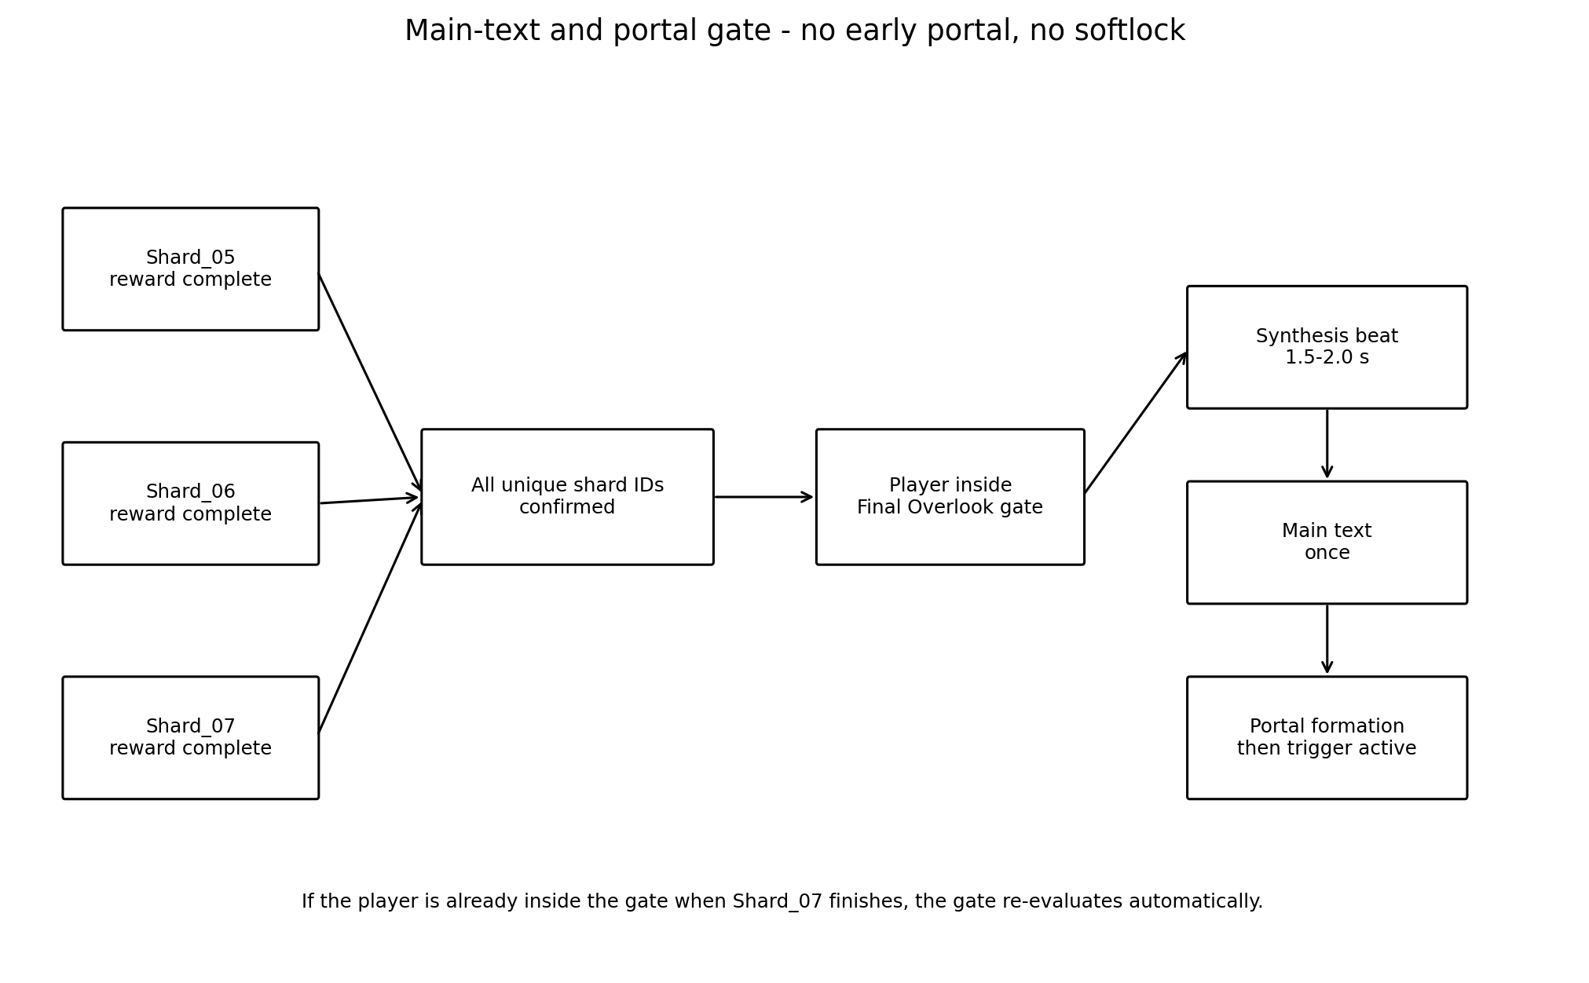
Figure 5. Main text and portal gate.
Field | Final behavior
Gate location | Final Overlook center Vector3(6.00, 1.60, 47.00), presence zone radius 4.5 m.
Gate prerequisites | Reward sequences complete for unique IDs Shard_05, Shard_06 and Shard_07.
Early arrival | Overlook remains explorable; no text or portal activation. Gate re-evaluates automatically when prerequisites become complete.
Synthesis | 1.5-2.0 s local environmental convergence. Player remains free until the main-text overlay opens.
Main text | Shows once. Portal Core remains dormant before and during text. Controls lock only if required by the existing overlay.
LevelPortalRoot / PortalFloorAnchor | Vector3(10.00, 1.60, 50.50). Gameplay Design locks only this root/floor placement anchor.
Shared internal offsets | The current shared LevelPortal internal visual and interaction offsets remain authoritative. Internal child world coordinates are not locked by Gameplay Design.
Shared geometry constraint | Shared LevelPortal geometry may not be changed without a separately approved compatibility blocker.
Technical verification | Godot Technical Architecture verifies the actual shared trigger envelope at the locked root/floor anchor.
Entry configuration | entry_mode = LevelPortal.EntryMode.AUTO_ENTER; require_entry_confirmation = false.
Activation timing | Portal activation begins only after main text closes. Formation/activation is one-way and idempotent.
Scene loading ownership | The portal owns scene loading. Level_03-local orchestration never calls a scene change directly.
Early-overlap contract | If the player enters the future portal area during formation and remains inside until activation completes, exactly one Level_04 transition occurs after activation. No early transition and no exit/re-enter requirement.
Compatibility escalation | If the current shared portal cannot satisfy early-overlap re-evaluation, Godot Technical Architecture must define a Level_03-local re-evaluation adapter or report a minimal shared prerequisite; the contract may not be silently weakened.
Activation fallback | If optional formation presentation does not complete, the shared activation completion path is invoked after 2.5 s without bypassing portal ownership.
Target scene | target_scene_path = "res://scenes/levels/Level_04.tscn".

11. Progress preservation, duplicate events and reload policy
Progress domain | Contract
Arch progression | Persistent within loaded scene; no reset on leaving Wind Trace.
Spark progression | Current perch/stage persists; no reset on leaving glade.
Meadow progression | Unique per-petal completion persists; any order; duplicate activation ignored.
Shard collection | Each unique canonical ID accepted once; duplicate collection/reward callbacks ignored.
Environment states | Derived from completed beats and unique shards; repeated requests are idempotent.
Main text | Once per scene completion; duplicate open/close signals ignored.
Portal | Formation and trigger activation are one-way states.

11.1 Full scene reload policy
MVP RELOAD POLICY
Because the current repository has no confirmed save/checkpoint framework for partial Level_03 state, a full scene reload resets Level_03 to the coherent initial state at Quiet Inlet. It must never reconstruct a partially active puzzle from stale scene-local state.

- No death loop exists, so normal play should not require a reload; fall recovery handles traversal mistakes.
- A later project save system may restore progress only from canonical unique shard IDs and puzzle-completion flags.
- If restoration is added later, the visual environment must be reconstructed before player control is returned.
- Reload during an overlay, hop, petal lift or portal formation must cleanly restart from E0 in the MVP.

12. Guidance and accessibility
Area | Rule
Navigation | Landmark silhouette, route framing, active wind ripple, warm motes and open sightlines. No minimap, arrow or quest marker.
Audio independence | Every mandatory rule is fully readable without sound. Sound may reinforce but never carry the only clue.
Color independence | Perches/petals differ by location, silhouette and motion; color is not the sole state indicator.
Motion sensitivity | No camera shake, rapid flashing, chase speed or full-screen pulse. Spark hops use smooth arcs and restrained bloom.
Cognitive load | Wind Trace has no failure; Spark uses fixed three-step sequence; Meadow is any-order and persistent.
Motor accessibility | No precision jump, timer or quick reaction. Meadow dwell is 0.65 s and does not require repeated button timing.
Text readability | Shard/main text shown in existing overlays; environment does not move the player during reading.
Hint escalation | Hints become clearer with idle time but never solve by teleporting or add a UI arrow.

12.1 Guidance escalation
Beat | Base | Assistance 1 | Assistance 2
Wind Trace | 0-20 s: normal glow | 20-35 s: stronger current arch | >35 s: ripple every 5 s
Playful Spark | 0-15 s: current perch ambient | 15-30 s: current perch pulse | >30 s: curved hint ribbon
Breathing Meadow | 0-25 s: normal petal breathing | 25-45 s: nearest inactive mote trail | >45 s: trail repeats every 6 s
Final return | 0-30 s: synthesis trail | 30-60 s: overlook landmark pulse | >60 s: stronger Final Overlook Landmark pulse + repeated synthesis ribbon/mote guidance
Arrival / Arch_01 activity check | 0-4 s: observe player activity | At 4 s without meaningful movement/camera change: Arch_01 pulse | No 6 s alternative

13. Failure and softlock matrix
Risk | Prevention | Fallback | Acceptance test
Player ignores Shard_05 and runs ahead | Spark remains noninteractive; Shard_05 and current arch/overlook receive escalating guidance. | Player can return along the same open route. | No future beat completes before Shard_05 reward.
Player crosses Arch_02/03 early | Inactive arches do not advance. | Once current arch completes, next becomes active. | No accidental sequence skip.
Player leaves Wind Trace halfway | Arch state persists. | Current arch continues hint cadence on return. | No reset.
Player leaves Playful Glade halfway | Spark waits at current perch. | Current perch pulses after return/idle. | No reset or lost spark.
Player approaches wrong perch | No effect; no negative sound. | Current perch/destination remains highlighted. | No punishment.
Spark hop presentation stalls | Logical hop timeout 1.2 s. | Place spark at destination and continue. | Shard_06 remains reachable.
Player is already near destination on arrival | 0.65 s settle prevents instant chain. | Normal proximity rule resumes. | No double-hop in one frame.
Player enters Meadow before Shard_06 | Petals remain ambient and visible. | Warm mote trail points back to current beat. | No premature Shard_07.
Player leaves petal dwell early | Only dwell progress resets. | Re-enter and dwell again. | Completed petals unchanged.
Player re-enters completed petal | Duplicate ignored. | Completed pulse only. | No count >3.
Two petal zones overlap | Spacing requirement prevents overlap. | If detected during Technical Architecture validation, revise the authored zones; never allow simultaneous completion. | Exactly one new completion per dwell.
Shard collected before reveal completes | Interaction disabled until reveal state. | Enable after visual or fallback timeout. | No invisible/early collection.
Duplicate shard signal | Unique ID already recorded -> ignore. | No duplicate reward/environment transition. | Count remains 3 max.
Reward overlay interrupted | Controller treats explicit completion or fallback timeout as terminal once. | Continue environment progression. | No blocked next beat.
Player falls from route | Only explicit SoftReturnVolume below world or authored out-of-bounds volumes can trigger recovery. | Exactly one teleport to latest valid RA; reset velocity; preserve progress; defer while reward/main-text lock active. | Standing still, slow movement and normal blockers never recover; one teleport per fall.
Player walks around visual boundaries | Natural blockers + authored out-of-bounds volumes behind edge composition; volumes do not overlap legal side spaces/overlooks. | Single recovery event if an authored boundary is bypassed. | Legal overlook exploration never triggers recovery.
Player reaches Final Overlook early | Gate remains unarmed; portal dormant. | After all rewards, gate re-evaluates if player is present. | No softlock or early portal.
Player does not go to Final Overlook | Synthesis motifs and landmark pulse escalate. | No teleport; route stays open. | Mandatory destination becomes readable.
Main text closes twice / unexpectedly | First valid close advances; later signals ignored. | Portal formation starts once. | No duplicate portal.
Portal activation presentation and shared completion diverge | Shared LevelPortal remains sole scene-loading owner; local orchestration requests activation once. | 2.5 s presentation fallback completes the shared activation path, not direct scene change. | No early transition; AUTO_ENTER works after activation.
Scene reload during partial completion | MVP resets full scene to E0. | All transient states cleared. | No mixed environment/puzzle state.
Duplicate petal completion callback | Each petal ID accepted once; completion set is idempotent. | Ignore duplicate callback and do not replay presentation. | Exactly 3 unique completions and one Shard_07 reveal.
Petal presentation completion races fallback timeout | Both paths converge on one atomic petal-complete guard. | First terminal path wins; second is ignored. | One segment update and one unique completion.
Spark hop completion races 1.2 s fallback | Hop stage has one terminal guard keyed by destination. | First completion places spark at destination; second ignored. | One stage advance and no skipped perch.
Duplicate main-text close | One main-text terminal flag. | First valid close requests portal activation; later closes ignored. | One activation request.
Duplicate portal activation completion | Shared completion handled idempotently. | Ignore duplicate completion callback. | Exactly one ready state and one scene transition.
Rapid portal enter/exit around activation | Shared portal tracks overlap and active state without direct local scene change. | Re-evaluate current overlap on activation; exiting removes eligibility. | No early or duplicate transition.
Player remains inside future portal area during formation | Portal is inactive until formation/activation completes. | On activation completion, re-evaluate overlap and AUTO_ENTER exactly once. | Exactly one Level_04 transition; no exit/re-enter.

14. Acceptance criteria

Layout and traversal
□ Footprint remains within X -22..+22 and Z -52..+54 unless Producer approves a change.
□ Mandatory route width is never below 5.5 m and has no mandatory gaps.
□ No required step exceeds 0.15 m; preferred slope <=8 degrees.
□ Final Overlook landmark is visible as a silhouette from Quiet Inlet.
□ Playful Glade reads as an oval glade, not a challenge arena; Meadow reads as an open field, not a hub.

Wind Trace / Shard_05
□ Only current arch advances; later arches cannot skip sequence.
□ All three full-width arch activations work at walk and run speed.
□ Leaving/re-entering never resets progress.
□ Shard_05 appears only after Arch_03 and exact locked text is used.

Playful Spark / Shard_06
□ Fixed A->B->C sequence; no random routing.
□ Next perch previews before each hop; spark never leaves the glade frame.
□ No timer, chase, wrong-input penalty or reset.
□ Shard_06 appears after final settle and exact locked text is used.

Breathing Meadow / Shard_07
□ Exactly three petals, all visible from entrance.
□ Any order works; each completion persists; no duplicates.
□ 0.65 s proximity dwell is readable and does not activate accidentally from the main route.
□ Shard_07 appears only after 3 unique completions and exact locked text is used.

Finale
□ Main text opens once only after all three reward sequences and Final Overlook presence.
□ Portal remains dormant before and during main text.
□ The shared LevelPortal becomes active only after main-text close and activation completion or the approved shared-path fallback.
□ Portal target is Level_04.

Tone and runtime safety
□ Initial world is naturally colored and alive, not grayscale or dead.
□ No enemy, damage, death, timer, precision jump, audio dependency or emotional-pressure mechanic.
□ All optional VFX can fail without blocking progression.
□ No unhandled duplicate event produces a second reward, text or portal.
□ All six Meadow petal permutations produce exactly three unique completions, one Shard_07 reveal, no duplicate count and no order-dependent state.
□ LevelPortalRoot / PortalFloorAnchor is Vector3(10.00, 1.60, 50.50); no internal shared-portal child world coordinates or trigger radius are locked by Gameplay Design.
□ target_scene_path = "res://scenes/levels/Level_04.tscn", entry_mode = LevelPortal.EntryMode.AUTO_ENTER and require_entry_confirmation = false.
□ A player remaining inside the future portal area through formation transitions exactly once after activation, without exiting and re-entering.
□ Duplicate/racing petal, spark, main-text and portal callbacks are idempotent and cannot advance twice.
□ Recovery occurs only through explicit authored recovery volumes, exactly once per fall, with velocity reset and state preservation; it never triggers during reward/main-text control lock.

14.1 Manual playtest matrix
ID | Setup | Action | Expected result | Area
PT-01 | Fresh scene | Remain idle/no meaningful camera change for 4 s, then walk normally. | Arch_01 pulses at exactly 4 s; no separate 6 s threshold; final landmark remains readable. | Navigation
PT-02 | Fresh scene | Run through each arch near left/right edge | Each full-width activation registers once. | Wind Trace
PT-03 | After Arch_01 | Leave to spawn and return | Arch_02 remains current. | Persistence
PT-04 | Before Shard_05 | Run into Playful Glade | Spark inactive; guidance points back; no softlock. | Gating
PT-05 | Spark at A | Approach B instead | No punishment; A remains current. | Wrong input
PT-06 | Spark hop | Stand at B before arrival | No double-hop; settle delay observed. | Race condition
PT-07 | Spark at B | Leave glade and return | Spark still at B; stage preserved. | Persistence
P0-PT-08 | Parameterized fresh Meadow state for each permutation | Run W-SE-NE; W-NE-SE; SE-W-NE; SE-NE-W; NE-W-SE; NE-SE-W. | Every order yields exactly 3 unique completions, one Shard_07 reveal, no duplicate count and identical final state. | Order invariance
PT-09 | Meadow after any completed permutation | Re-enter all three completed petal zones. | No order-dependent residue and no additional completion. | Persistence
PT-10 | Petal dwell | Enter for 0.3 s then leave | No activation; completed petals unaffected. | Input
PT-11 | One petal complete | Re-enter completed zone repeatedly | No duplicate count. | Idempotency
PT-12 | Any route segment | Fall into SoftReturnVolume and authored out-of-bounds volumes; also stand still, move slowly and touch normal blockers. | Exactly one recovery per fall, velocity reset, progress preserved; legal behavior never triggers recovery. | Recovery
PT-13 | Before Shard_07 | Reach Final Overlook | No main text or portal. | Early arrival
PT-14 | Already in final gate | Complete final prerequisite via debug setup | Gate auto re-evaluates and starts finale. | Gate safety
PT-15 | All shards complete | Do not return for 60 s | Guidance escalates without UI arrow. | Guidance
PT-16 | Main text open | Close normally | Shared LevelPortal activation is requested once; scene entry remains unavailable until activation completes. | Finale
P0-PT-17 | Portal formation in progress | Enter future portal area and remain inside through activation. | No early transition; exactly one Level_04 transition after activation; no exit/re-enter. | Early overlap
PT-18 | Duplicate shard callback | Fire same ID twice in QA | Second ignored; no second reward/effect. | Duplicate
PT-19 | VFX intentionally missing | Complete every puzzle | Fallback still exposes all shards/text/portal. | Fail-safe
PT-20 | Partial scene state | Reload scene | Clean E0 reset at spawn; no stale VFX. | Reload
PT-21 | Normal first-time player | Blind completion | 5:30-7:00 typical; <=8:00 review limit. | Pacing
PT-22 | Experienced player | Correct repeat completion | 3:00-4:00 typical; <=4:30 maximum. | Pacing
P0-PT-23 | One petal logical completion already accepted | Fire duplicate completion callback for the same petal ID | Unique completion count unchanged; no repeated segment/presentation; one Shard_07 max. | Duplicate petal
P0-PT-24 | Petal presentation near timeout | Complete presentation and fire fallback timeout in the same frame/order variants | One atomic terminal result; one segment and one unique completion. | Petal race
P0-PT-25 | Spark hop near 1.2 s timeout | Fire real hop completion and fallback in both possible orders | Spark reaches one destination; stage advances exactly once; no skipped perch. | Spark race
P0-PT-26 | Main text open | Emit two close/completion events rapidly | Portal activation requested exactly once. | Duplicate text close
P0-PT-27 | Portal activation completing | Emit duplicate shared activation completion | One ready state and at most one Level_04 transition. | Duplicate portal completion
P0-PT-28 | Portal active boundary | Rapidly enter/exit/enter around activation completion | No early transition; current overlap state is respected; never more than one transition. | Portal overlap race
P0-PT-29 | Player in future portal area before activation | Remain overlapping until activation completes | AUTO_ENTER transitions exactly once after activation without requiring re-entry. | Mandatory early overlap
P0-PT-30 | Reward/main-text control lock active | Force player body into a recovery volume | No recovery during lock; after lock, a valid fall produces one teleport with zeroed velocity. | Recovery lock

15. Simplification fallback and technical handoff boundary
Problem | Approved simplification
Wind Trace VFX too costly | Keep three arches and proximity order; replace ribbons with emissive pulse + grass wave. Do not cut Shard_05.
Playful Spark reads as mascot/childish | Emergency fallback: three seed-pod perches react sequentially with the same A->B->C state and timings.
Spark movement technically unstable | Teleport between perches only behind a short arc/dissolve, preserving deterministic sequence and destination telegraph.
Proximity petals feel accidental | Switch all three petals to one consistent E interaction. Do not mix verbs within the meadow.
Petal objects feel collectible-like | Fallback calm-zones at the same coordinates, using proximity dwell and the same 3 persistent IDs.
Environment transitions too expensive | Use bounded light/fog/material interpolation only; logical progression must remain unchanged.
Scope pressure | Cut decorative VFX layers and optional camera emphasis first. Do not cut a shard, main text, recovery or duplicate protection.

15.1 What to pass to Godot Technical Architecture stage
- The coordinate tables, route centerline, dimensions, clearances and recovery contracts in Sections 3-4.
- The functional puzzle states and deterministic transition conditions in Sections 6-8, including P0 race contracts.
- The hybrid gate rule: Shard_05 -> Shard_06 -> Shard_07, with any-order petal IDs.
- The one-time main-text and shared-LevelPortal ownership/overlap behavior in Section 10.
- Fall recovery anchors and the MVP full-reload reset policy.
- The failure matrix and manual playtest IDs as Technical Architecture verification requirements, not implementation authorization.
- Godot Technical Architecture must inspect the current shared shard/reward/LevelPortal contracts and report compatibility, required local adapters or minimal shared prerequisites. No runtime work is authorized by this document.

15.2 What remains deferred and unauthorized
- Final Godot node hierarchy, class names, signals, APIs and controller ownership are outputs of the later Godot Technical Architecture stage, not this document.
- Blender meshes, pivots, UVs, collision generation, GLB hierarchy and all Art Production Bible work remain unauthorized.
- Final shader parameters, audio assets, camera animation curves and runtime implementation remain unauthorized.
- A global save/progression framework, Greybox Development Reference and Codex implementation decomposition remain unauthorized.

16. Producer decision table
ID | Decision | Requested status | Recommended result
PD-01 | Exact gameplay footprint and coordinates | APPROVE | 44 x 106 m; anchors in Sections 3.2-3.4.
PD-02 | Hybrid progression order | APPROVE | Linear macro; any-order Meadow.
PD-03 | Breathing Meadow activation verb | APPROVE / ADJUST | Recommended proximity dwell 0.65 s; fallback E interaction.
PD-04 | MVP reload policy | APPROVE / ADJUST | Full coherent scene reset; no partial save restoration.
PD-05 | Fall recovery policy | APPROVE | Explicit SoftReturnVolume/OOB volumes only; one teleport; velocity reset; preserve state; no lock-time recovery.
PD-06 | Early access to future spaces | APPROVE | Physical route remains open; future beats inactive until prerequisites.
PD-07 | Pacing budget | APPROVE | First 5:30-7:00; 8:00 scope alarm; repeat 3:00-4:00.
PD-08 | Final text/portal gate | APPROVE | All rewards + Final Overlook; portal after text; shared AUTO_ENTER ownership and early-overlap re-evaluation.
PD-09 | Single shared LevelPortal root/floor anchor | APPROVE | Vector3(10.00, 1.60, 50.50); internal offsets/radius verified later by Technical Architecture.
PD-10 | Production gate | APPROVE | After approval, proceed only to Godot Technical Architecture stage.

FINAL DOCUMENT STATUS
READY FOR GODOT TECHNICAL ARCHITECTURE AFTER PRODUCER APPROVAL. After Producer confirms PD-01 through PD-10, this document may be used only as input to the Godot Technical Architecture stage. It does not authorize Godot scenes or scripts, runtime branches or PRs, greybox implementation, Blender/GLB production, Art Production Bible work, Greybox Development Reference or Codex implementation decomposition.

Appendix A. Canonical text and emotional safety
Item | Locked copy
Shard_05 | После наших разговоров я ещё долго вспоминаю твою интонацию.
Shard_06 | Мне особенно нравится, как ты вдруг смеёшься над какой-нибудь полной ерундой.
Shard_07 | Рядом с тобой я и сам чаще смеюсь и ненадолго перестаю быть таким серьёзным.
Main text | Сначала я просто заметил, что жду наших разговоров. Потом понял, что после них ещё долго вспоминаю твою интонацию, а когда ты внезапно смеёшься над какой-нибудь ерундой, я и сам перестаю быть таким серьёзным. Мне дорого не только то, как легко мне бывает рядом с тобой. Мне дорога ты.

- The heroine is not broken and is not repaired.
- Her light and worth already belong to her.
- The level depicts the author's memory and emotional response, not an obligation for her to talk, laugh or remain available.
- No confession, answer choice, rejection/acceptance prompt or emotional debt appears in Level_03.

